

**How do socio-demographic and mass media factors influence the tobacco consumption patterns of men in India?: Findings from National Family Health Survey (NFHS) – 5**

**IBM-2021**

**Group Members:**

Neha Chowdary Ananthaneni – 21020366

Perne Harish Chandra – 21020103

Srestha Patel – 21020224

Diya Peeter – 21020392

Under the guidance of Dr. Karan Babbar

**Date of Submission** – 10th May 2023

**TABLE OF CONTENTS**

|  |  |  |
| --- | --- | --- |
| S.NO | CONTENTS | PAGE NUMBER |
| 1 | Abstract | 3 |
| 2 | Introduction | 4 |
| 3 | Methodology | 5 |
| 4 | Results | 7 |
| 5 | Limitations | 10 |
| 6 | Conclusion | 11 |
| 7 | References | 13 |

**ABSTRACT**

Our study’s objective is to study various socio demographic and mass media factors influencing tobacco consumption patterns among men in rural and urban demographics in India. We have made utilization of data from the Indian version of the fifth round of the National Health and Family Survey (NFHS) conducted from 2019 to 2021. With a sample size of 101839 men aged from 15 to 54 from both rural and urban demographics. Linear regression was performed to understand the determinants of tobacco consumption. With the finding of the analysis, we found younger age groups, lower education levels, and lower-income groups were found to be more susceptible to tobacco consumption. Mass media determinants also had a strong influence on consumption patterns. From our research, we found certain policies could be implemented such as tightening tobacco consumption on an age basis restriction, advertising and mass media education could help more awareness of the consumption hazards of tobacco. Implanting more approachable cessation services would be a great move.

**INTRODUCTION**

Tobacco use is a major risk factor for numerous chronic diseases, including cancer, lung disease, cardiovascular disease, and stroke. It is one of the leading causes of death and disease in India, accounting for over 1.35 million deaths per year.

India is also the world's second-largest consumer and producer of tobacco, with 761,335 tons produced in three states and approximately 25 million people employed across the value chain. Tobacco usage is one of the world's most serious public health hazards. It not only results in the loss of life but also has significant social and economic consequences.

According to the National Family Health Survey (NFHS)-5 survey, which was conducted in 2019-21, tobacco smoking is more widespread among men, the rural population, illiterates, the poor, and vulnerable members of society. The tobacco situation in India is extremely complex, with a wide range of smoking styles and smokeless tobacco products being widely used. Many of these products are made in cottage and small-scale industries with varying mixtures and vastly different manufacturing processes. The most widespread type of tobacco usage in India is smokeless tobacco, and popular products include khaini, gutkha, betel quid with tobacco, and zarda. Tobacco smoking methods include bidi, cigarettes, and hookah.

The distribution of tobacco consumption, however, is not uniform. Tobacco use is frequently observed to be disproportionately greater in lower socioeconomic groups. However, apart from a few local studies, only a little systematic research has been conducted into how tobacco consumption is distributed socioeconomically and geographically in India. To determine which persons are most likely to consume tobacco and which places are more likely to have increased cigarette consumption, gaps in tobacco consumption must be investigated. Such assessments are crucial for developing policies and interventions to reduce total tobacco consumption at the population level and inequalities in susceptibility to cigarette intake.

In this research, we investigate how tobacco consumption is varied across a range of socio-demographic and mass media factors at age and wealth indices in India. Conditional to this we also examine and analyze the relationship between these socio-demographic factors and tobacco consumption of men in India.

**METHODOLOGY**

**Sources of data**

This study has used the nationally representative, large-scale, publicly accessible Demographic and Health Survey, popularly known as National Family Health Survey-5 (NFHS-5) conducted in 2019-21. This survey is administered by the Ministry of Health and Family Welfare in coordination with the International Institute of Population Sciences, Mumbai. The study was collected from 101839 adults. All men aged 15-54 years were eligible to take part in the survey.

The analysis was based on a representative, cross-sectional 2019-2021 National Family Health Survey (NFHS-5) of 101839 adults aged 15-54 from rural and urban regions. The data obtained through an interview-based structured questionnaire and answered by households and individuals provide a range of demographic and socioeconomic factors on all the members of the household including information on smoking cigarettes and not smoking.

**Sample and study design**

We referred to and analyzed data from the 5th round of the national family health survey. We took data from a ginormous cross-sectional survey conducted between 28 states and 8 union territories. The data was conducted in the years between 2019 to 2021. Data from men aged 15 to 54 were collected. We divided the data collected into different subgroups: smoking and smokeless (not smoking) tobacco used and consumed by men among the data collected, and from taking homogenous data we divided further subpopulations and formed strata. Data is further divided into certain other categories taken from strata and certain factors were ascertained, such as: spatial factors like the area of residence and socio-demographic factors like age, education level, and mass media factors like radio, television, and economic capabilities of the men in the population were taken to evaluate the data set presented. We used stratified sampling to categorize and structure our data.

**Dependent Variables**

The following questions have been considered to identify dependent variables for this study using the National Family Health Survey-5 which was conducted in the year 2019-21 questionnaire.

The tobacco consumption in India is more complex than any other country in the world with the use of a variety of smoking and smokeless tobacco products. The primary outcome of this research was tobacco usage. We focussed on the question, Do you currently smoke cigarettes, with the response as yes or no? In this, people who are using cigarette, bidis are considered to be using and others as not using tobacco.

**Independent variables**

Based on our research, we have used several independent variables in the study including Age (15-54 years), education level of the respondent (no education, primary, secondary, higher), Religion (Hindu, Muslim, and others), wealth index (poorest, poorer, middle, richer, richest), frequency of reading newspaper, watching television, and listening to radio.

**Control Variables**

The response variables used in this research are the usage of tobacco and cigarette. The control variables considered in this research are the age, education level, and religion of the respondents. We have also considered other factors such as education level, wealth index, religion, and the usage of media as well.

**Data Analysis**

We have performed our data analysis through descriptive statistics and a linear regression model. We started our preliminary investigation with the descriptive statistics for smoking and smokeless (not smoking) tobacco consumption of men in India. Then we performed linear regression separately for smoking and smokeless data to understand how socio-demographic and mass media factors impact tobacco consumption in men of India. Regression analysis is done between smoking cigars (smoking and smokeless) and the socio-demographic exposures. We adjusted all selected socio-demographic and mass media exposures in X variables of regression and smoking cigars in the Y variables. We used data analysis software in Microsoft - Excel 365 version.

**RESULTS**

**Descriptive statistics of various socio-demographic factors**

Descriptive statistics for all the key variables used in the study are presented in Table 1. The study uses data for 101,839 men in the age group of 15 to 54 who participated in the NFHS-5 survey. Around 14 percent of the men in our sample are smoking, whereas 86 percent are smokeless (not smoking). Men from the age of 25 to 29 have been found dominant in smoking cigars. In smoking, around 14 percent of the men belong to rural regions and followed by 15 percent of the men belonging to urban regions. About 31 percent of men who are smoking belong to the lowest two wealth strata (the poorest and the poor) compared to only 24 percent of men who are from higher wealth strata ( the richest and the rich).

Men from other religions are found dominant in smoking cigars followed by Muslims. Twenty-six percent of men who completed secondary education are found smoking compared to thirty-two percent of men who have no education and completed primary education. Around 19 percent of the households who are smoking watch television frequently.

**Table 1** Descriptive statistics of tobacco usage by different variables

|  |  |  |
| --- | --- | --- |
| Background Characteristics | Smoking |  |
|  | Number | % |
| Age |  |  |
| 15-19 | 1016 | 6.09 |
| 20-24 | 1982 | 13.75 |
| 25-29 | 2474 | 17.22 |
| 30-34 | 2287 | 17.20 |
| 35-39 | 2177 | 16.91 |
| 40-44 | 1723 | 15.89 |
| 45-49 | 1678 | 15.48 |
| 50-54 | 1219 | 14.22 |
|  |  |  |
| Area of Residence |  |  |
| Urban | 4040 | 15.29 |
| Rural | 10516 | 13.94 |
|  |  |  |
| Educational Level |  |  |
| No Education | 1859 | 15.15 |
| Primary | 2003 | 17.10 |
| Secondary | 8565 | 14.27 |
| Higher | 2129 | 11.93 |
|  |  |  |
| Religion |  |  |
| Hindu | 9260 | 11.99 |
| Muslim | 1869 | 15.43 |
| Others | 3427 | 27.38 |
|  |  |  |
| Wealth Index |  |  |
| Poorest | 2972 | 15.01 |
| Poorer | 3632 | 16.07 |
| Middle | 3227 | 14.86 |
| Richer | 2743 | 13.57 |
| Richest | 1982 | 11.31 |
|  |  |  |
| Newspaper |  |  |
| Not at all | 4507 | 9.79 |
| No more than once a week | 3630 | 13.12 |
| At least once a week | 6419 | 22.78 |
|  |  |  |
| Radio |  |  |
| Not at all | 10580 | 13.55 |
| No more than once a week | 2576 | 15.94 |
| At least once a week | 1400 | 18.37 |
|  |  |  |
| Television |  |  |
| Not at all | 1457 | 6.68 |
| No more than once a week | 3041 | 10.89 |
| At least once a week | 10058 | 19.29 |
|  |  |  |
| Total Sample Size | 14556 | 100 |

**Regression analysis of socio-demographic factors affecting tobacco consumption in men**

The results of the regression model are shown in Table 2. If smoking cigars increases by one unit then age increases by 0.001, area of residence decreases by 0.03, education level decreases by 0.0003, religion increases by 0.002, wealth index decreases by 0.016, newspaper decreases by 0.012, radio increases by 0.03 and television increases by 0.017.

As the age keeps on increasing the smoking level increases by 0.001. From the regression of area of residence, we can see that men from rural areas smoke more as compared to men from urban areas. As the education level keeps on increasing from no education to higher, smoking cigars decreases by 0.0003. The analysis shows that people from Hindu smoke more as compared to people from the Muslim category. As the wealth index changes from poorest to richest the smoking cigars decreases by 0.016.

Considering the other mass media factors from the table we can interpret that the number of people who don’t read newspapers at least once a week smokes cigars decreases by 0.012. Whereas the number of people who don’t listen to the radio at all to at least once a week smokes cigars increase by 0.031. From our analysis, we found that the number of people who don’t watch television to at least once a week smoke cigars increases by 0.017.

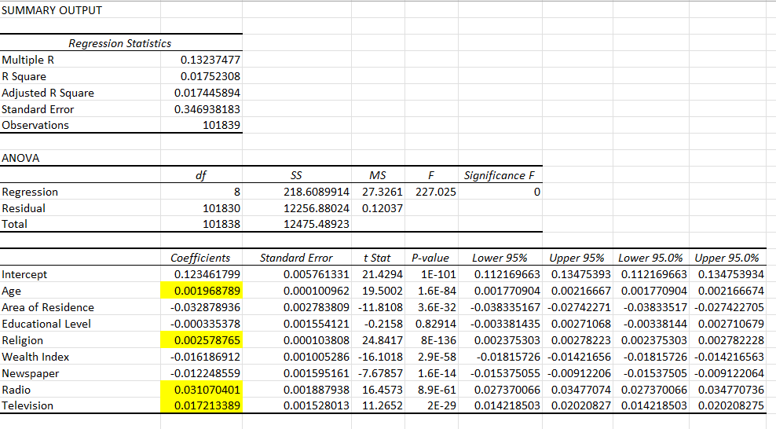**Table 2** Regression analysis of tobacco usage with different variables

**LIMITATIONS**

According to the National Family Health Survey 5 (NFHS-5) conducted in India, there were several socio-demographic and mass media factors that can influence the tobacco consumption patterns of men in India. Some of the factors and their limitations are:

Age: older men in India are more likely to consume tobacco than younger men. However, this may not always hold true as some younger men may also consume tobacco but may not be captured in the survey data.

Education: men with lower levels of education are more likely to consume tobacco than those with higher levels of education. However, the survey does not capture the quality of education, which may also influence tobacco consumption patterns.

Wealth Index: Men with lower income levels are more likely to consume tobacco than those with higher income levels. However, the survey does not capture the socio-economic status of the individuals, which may also influence tobacco consumption patterns.

Mass media exposure: Men who are exposed to tobacco advertisements through mass media are more likely to consume tobacco. However, the survey does not capture the specific types of media exposure that may influence tobacco consumption patterns.

The survey only covers households in urban and rural areas and may not fully capture the diversity of tobacco consumption patterns across different regions and communities in India.

**CONCLUSION**

The findings from the National Family Health Survey (NFHS) - 5 shed light on the influence of socio-demographic and mass media factors on tobacco consumption patterns among men in India. The study provides valuable insights into the factors that contribute to tobacco use and highlights the need for targeted interventions and policies to address this public health issue.

The socio-demographic factors identified in the NFHS-5 findings align with our research, emphasizing the role of age, education, area of residence, and wealth index. Younger age groups, lower education levels, and lower-income groups were found to be more susceptible to tobacco consumption. These findings underscore the importance of tailoring interventions to specific demographic groups as people from urban areas smoke a lot more than those from rural areas. For instance, targeted educational campaigns can raise awareness among younger men about the harmful effects of tobacco and provide them with coping mechanisms to resist peer pressure.

Mass media factors also emerged as influential in shaping tobacco consumption patterns. The NFHS-5 findings highlight the impact of tobacco advertising on men's tobacco use, emphasizing the need for stricter advertising regulations. Implementing and enforcing comprehensive bans on tobacco advertising, including a prohibition on indirect advertising and sponsorships, would reduce the exposure of men to pro-tobacco messages and imagery.

Based on these findings, a recommended policy intervention is the implementation of a comprehensive tobacco control program. This program should focus on multiple strategies, including:

* **Strengthening tobacco control policies:** Implementing and enforcing comprehensive tobacco control policies, such as smoke-free laws, advertising restrictions, and increased taxation, to create an environment that discourages tobacco use.
* **Mass media campaigns:** From the regression analysis we can interpret that mass media factors can help in both increasing and decreasing the consumption of tobacco in men of India. Developing and disseminating targeted mass media campaigns on newspapers, radio, and television that highlight the health risks associated with tobacco use and promote quitting. These campaigns should aim to counter the influence of pro-tobacco messages and imagery.
* **Education and awareness programs:** We can see that the individuals who completed their secondary education led to a decrease in smoking cigars from the regression analysis. Implementing educational initiatives that raise awareness about the harmful effects of tobacco use, particularly among vulnerable populations, and provide support for tobacco cessation.
* **Enhancing accessibility to cessation services:** Ensuring that affordable and accessible tobacco cessation services are available to men who want to quit, including counselling, nicotine replacement therapy, and pharmacological interventions.

By implementing a comprehensive tobacco control program that addresses socio-demographic and mass media factors, India can make significant strides in reducing tobacco consumption among men. This would contribute to improved public health outcomes, decreased tobacco-related diseases, and a healthier future for the population.

**REFERENCES**

Islam, M. S., Saif-Ur-Rahman, K. M., Bulbul, Md. M., & Singh, D. (2020). Prevalence and factors associated with tobacco use among men in India: Findings from a Nationally Representative Data. *Environmental Health and Preventive Medicine*, *25*(1). <https://environhealthprevmed.biomedcentral.com/articles/10.1186/s12199-020-00898-x>

Subramanian, S. V., Nandy, S., Kelly, M., Gordon, D., & Smith, G. D. (2004, April 1). *Patterns and distribution of tobacco consumption in India: Cross sectional multilevel evidence from the 1998-9 National Family Health Survey*. The BMJ. <https://www.bmj.com/content/328/7443/801>

B.Karuppusamy, W.Paulson, S.Chellappan, S.K.Behera, & P.Balabaskaran Nina. (2021, April 20). *District-level epidemiology, hot spots and sociodemographic determinants of tobacco use in Indian men and women: Analysis of national family health survey-4 (2015–16)*. Public Health. <https://www.sciencedirect.com/science/article/pii/S0033350621001086>

Babbar, K., Saluja, D., & Sivakami, M. (2021). How socio-demographic and mass media factors affect sanitary item usage among women in rural and Urban India. *Waterlines*, *40*(3), 160–178. <https://practicalactionpublishing.com/article/3045/how-socio-demographic-and-mass-media-factors-affect-sanitary-item-usage-among-women-in-rural-and-urban-india>